ROLES IN RUGBY UNIT/DAY 2
The Manager
- Equipment needed
- 2 rugby
- 4 cones (set up a playing field 30 yards by 20 yards)
- 2 colored dome cones 5 yards from try line on touch-line/sideline
- 5 jerseys (only if team members not wearing their color)

Perform the tasks for the day and he/she return all equipment to its proper location after class.

The Warm up (Video example Just don’t have first person follow pass)
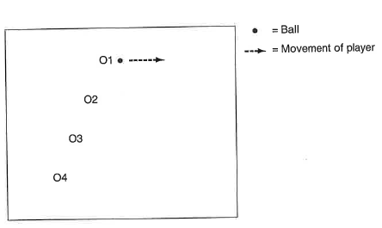
In teams, practice running in a stagged line and passing. 01, 02, 03 and 04 (if 5 uses all 5 players) run forward at the same pace, and 01 begins with the ball. With 02 off their shoulder , 01 passes to 02 who accelerates to get ahead to 03 before passing. 03 accelerates and passes to 04. Switch the middle players and restart.
Cues:
- Accelerate when you receive
- Slow after you pass
- Swing the arms across the body
- Aim in front of the receiver’s chest
Extension: Pass down the line and back. 04/05 sends the ball back to 03 after receiving and the practice ends with 01 scoring a try

The scorekeeper
- The scorekeeper helps keeps score of scrimmage games (fill out sheet and turn into team folder); Only record touchdowns and final score. Record How many students are wearing team color (there is a daily point sheet to keep track of).

Referee
-Help in officiating during scrimmage. You still play. Help team understand vocab and rules used in practice and scrimmage. Assist captain and coach when needed.

Captain
-The captain retrieves their team’s folder and takes attendance for their team.
-The captain also leads the team when starting the scrimmage “Rock-Paper-Scissors” “and shaking the hands after game.
-The captain leads the team meeting; students give one positive and one corrective feedback for their teammates.

Task | Description | Focus | Time
2-Person Quickie  (e) Support on the left side  (e) Add a pass back to the half (this person is technically no longer the half) Video Example | -ball carrier pretends making touch on defense (yes that’s right). Put ball down and step over the ball (static).  -After putting the ball down support the half on the right side of them  -Half picks it up and throws back quickly to ball runner  -Set up continuous or have 1 group of 2 going and another group of 3 going  Points of emphasis  Ball Carrier:  -Quickly get in a position to support the half  Half  -Crouch and face the supporting teammate  -Try to pass the ball from the ground | - Learn the half and how to restart after a touch  - Learn how to quickly restart after a touch  - Learn how to quickly support your team | 2-3 Mins  (e)2-3 mins  (e)2 mins
2v1 Quickie (set up in a 20x20 grid)  (e) If needed allow offense to have more touches (i.e 3)  (e) Increase distance (30x20) Offense gets 3-6 touches to score  (e) add on official | Same as above but this time add a defender 5 yards off of where the offensive players start. Offensive player runs straight at defender and initiates.  -After first touch defense can play full defense.  -play stops if defense makes a second touch (i.e. one more)  Points of emphasis  Defender:  -retreat quickly 5 yards from mark before trying to touch  Offense:  -after the half makes first pass, reading the defense correctly to either pass or keep the ball | - Offense learns how to apply using a 2-person quickie  - Defense learns to quickly retreat 5 yards before trying to make another touch | 3 min  (e) 2-3 mins  (e)2-3 mins
3 man drive/Rucking (Shadow) 20x 10 yard box  (E) Go down and back in a 20-30 yard  Video Example of 3 person Rucking | -ball carrier simulates making touch on defense (yes that’s right). Put pall down and step over it and lightly touching the ball (static) or rolling the ball back with their foot.  -The offensive player who picks up the ball is the acting “half” and picks up the ball quickly and throws it to third teammate (who is wide). Receiver runs just 5 yards pass the half.  -Make Just one pass and rotate  Points of emphasis  Ball Carrier:  -The ball roll may not roll more than 3 feet (1 yard).  -Take the initiative in touching the opposition  Half:  -Crouch and face the supporting teammate  -Try to pass the ball from the ground  Receiver:  -hands pointing to the passer  -be accelerating on the catch | - To learn the 3 person rucking/drive pattern  - The importance of not over-running the touch, since this wastes time coming back to the mark  - To roll the ball quickly  - To communicate with the acting half as the receiver  - Learn the offside rule and the penalty | 2-4 Mins  (Make sure they have this down before moving on)  (e) 2 mins
(e) 3v2 Rucking  (20x30 yards field)  (e) The half can run forward with it before passing (if they are touched before passing it’s a turnover) | 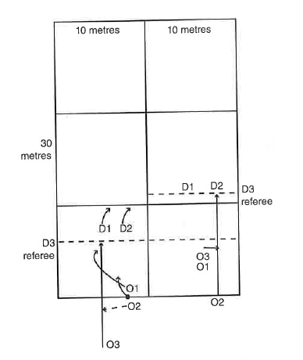  -Same as above and similar to 2v1 quickie. Defense still allows first touch. After that its full defense. They have 3-6 touches to score  Points of emphasis  Ball Carrier:  Has to make sure they initiate step over or ball roll at the mark.  Modifications/Challenges  -Must use the rucking pattern at least two times before scoring  -Allow 2 possession (i.e. not a turnover if they drop the ball) | - To ruck and run the ball efficiently so as to catch defenders offside  - Learn the offside rule and the penalty | 3-5 mins  (e) 2-3 mins
Team Meeting | -Review team chant.  -Review Pre-game: Shake other teams hands, give team chant. Captains do rock-paper-scissors to see who starts with ball.  -Practice post-game:  -Stat keeper gets handout (in team folder) to keep stats of scrimmage games (just TD’s for your own team and overall score) |  | 3-5 Mins
4v3 Scrimmaging | 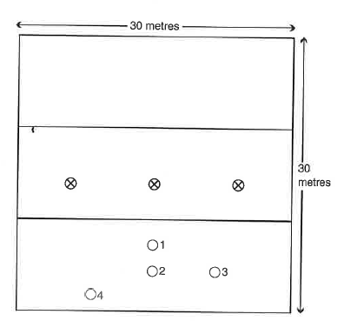  Each team gets 5 possessions and then switch roles. On a change of possession Ball restarts 30 yards away with a tap. Every possession captains need to make sure you are rotating players in.  Sports commissioners will officiate games.  Referee will be checking:  -Checking if defense was retreated the correct distance and enforcing a penalty  -Observing the mark and making sure the ball is passed in correctly  -passing after the touch=penalty  -Forward Pass=penalty  -droped ball or fumbled ball = loss in possession  -Roll the ball more than 3 feet=loss of possession  -Defenders offside=penalty this is a tap taken from where the defender should have retired to | - Illegal roll ball results in a change of possession turnover  - An intercepted pass usually results in a score by the opposition  - An unsuccessful interception that is knocked to the ground results in another six attempts by the attackers to score  - A dropped or missed pass results in a change of possession  - Defenders who do not retire quickly are caught offside will draw a penalty | 10-15 mins  We will try to scrimmage every team
Closing Team Meeting | Complete debrief-Captain Leads out |  | 6-10 mins
Class Meeting | Answer question-CFU’s |  | 3-5 mins

